**Online CCA Registration**

**USER GUIDE for**

**STUDENTS**

Table of Contents

Login 1

CCA Registration 3

Information 4

Choices 5

Background 6

Print Confirmation Slip 7

Sample Confirmation Slip 8

# Login

URL: <https://hougang.schoolhub.sg/>

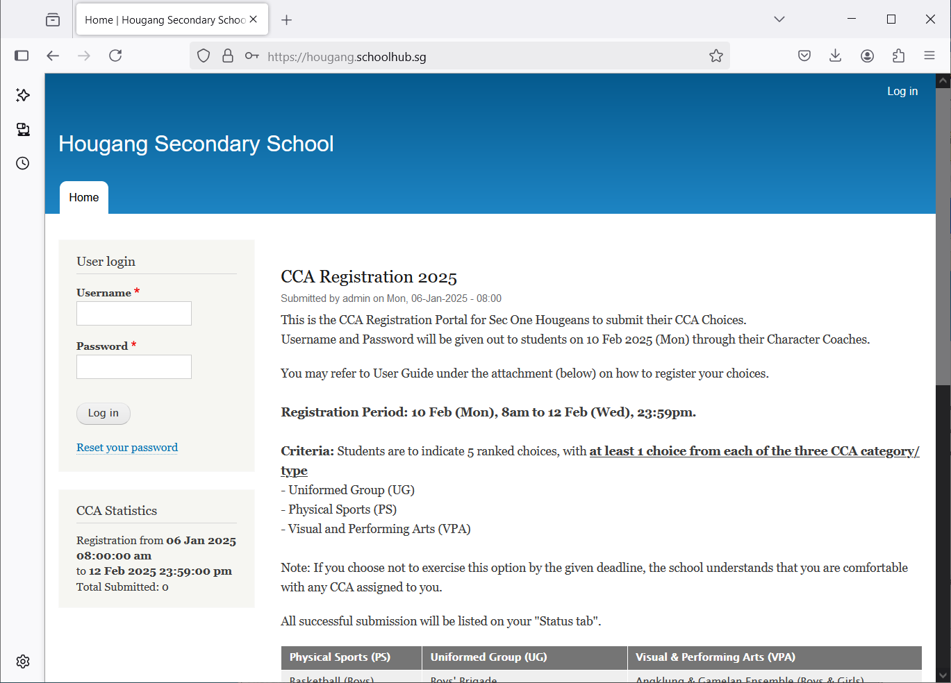

Steps

* Enter Username
* Enter Password
* Click Log in button

Upon successful login, you will be able to see the CCA Registration link under Pupil Menu.

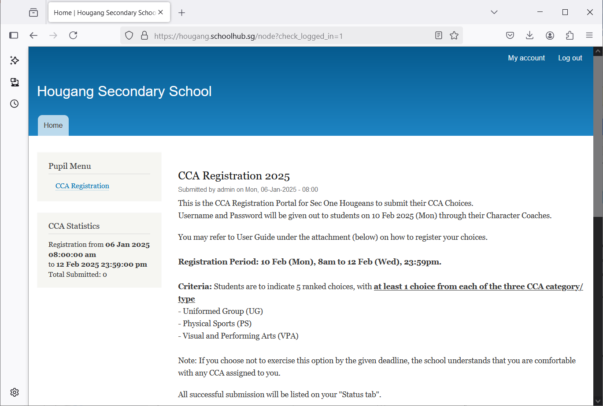

CCA Registration

Read the Announcements

Steps

* Click on CCA Registration button to begin

# CCA Registration

If you have not registered, you will see this message: “You have not submitted yet”.

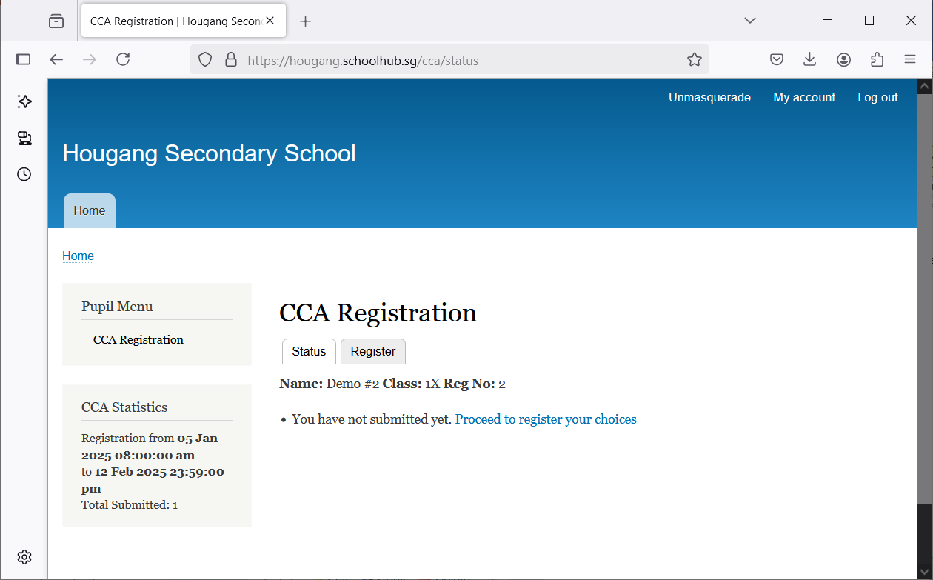

Click Register to begin

## Information

There are 3 sets of information required:

* *Choices (Your choice of preference)
  + You must enter all the choices
  + Each choice must be different
* Background (Primary School Background)
  + Previous School CCA
  + Special Talent
  + Remarks

**Fields with * are compulsory.**

## Choices

You shall indicate your choice of preference with Choice No 1 as your most preferred choice, follow by Choice No 2, Choice No 3 etc

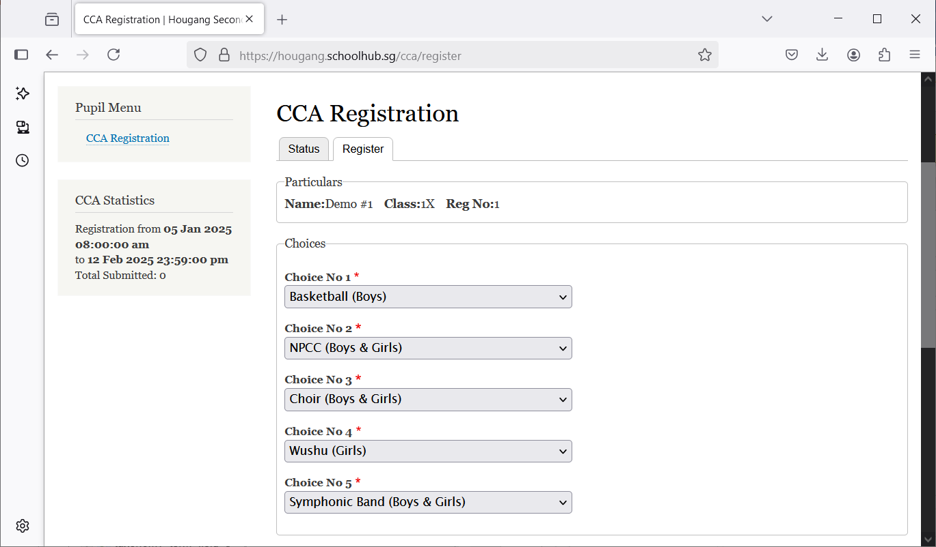

Steps

* Fill in all your choices

## Background

These are your Primary School Background.

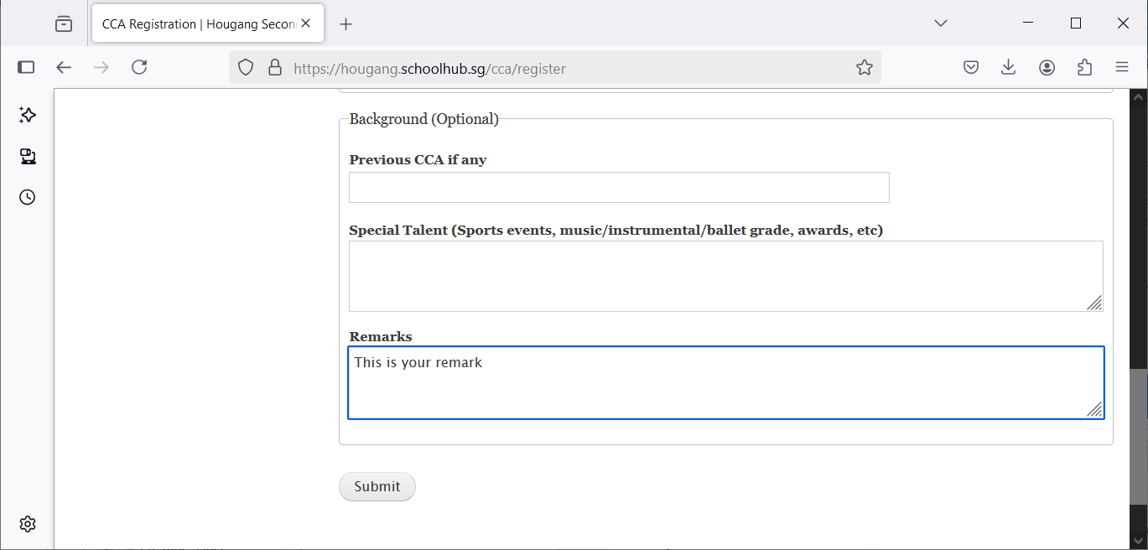

Steps

* Fill in all the information, if available
* Click Submit button

# Print Confirmation Slip

Once you have clicked Submit, you will be redirected to the Status Tab where your choices will be displayed.

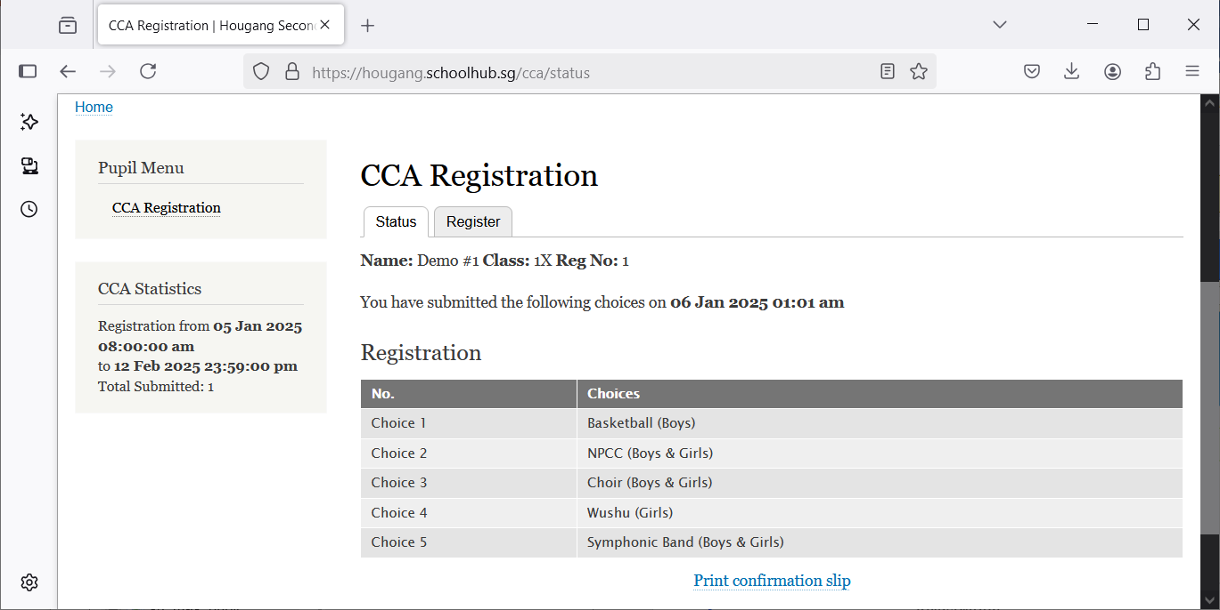

Steps

* Click Print Confirmation Slip button (to save a PDF copy of your submission)

## Sample Confirmation Slip

